Assignment-2

|  |  |
| --- | --- |
| AssignmentDate | 19September2022 |
| StudentName | Chandru.R |
| StudentRollNumber | 310119104023 |
| MaximumMarks | 2Marks |

Question-1:

Createusertablewithuserwithemail,username,rollnumber,password

CREATETABLEuser3(

roll_number int,username varchar(300),emailvarchar(300),

passwordvarchar(300)

);

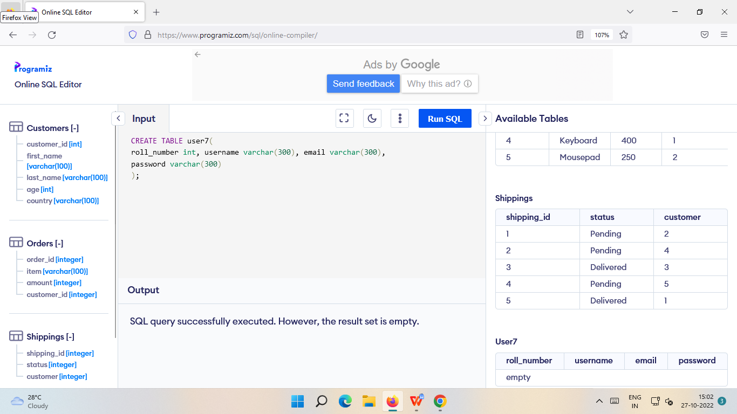

1.PerformUPDATE,DELETEQuerieswithuser table

**INSERTStatement:**

# INSERTINTOusers3(roll_number,username,email,password)VALUES(1,'Swetha','swetha80@gmail.com','Swetha80'),

(2,'Vidya','vidya1@gmail.com','vidya1'),

# (3,'Supriya','supriya02@gmail.com','supriya02'),

(4,'Shivapriya80','shivapriya06@gmail.com','shivapriya02'),

(5,'Pavithra03','pavi@gmail.com','Pavithra03');

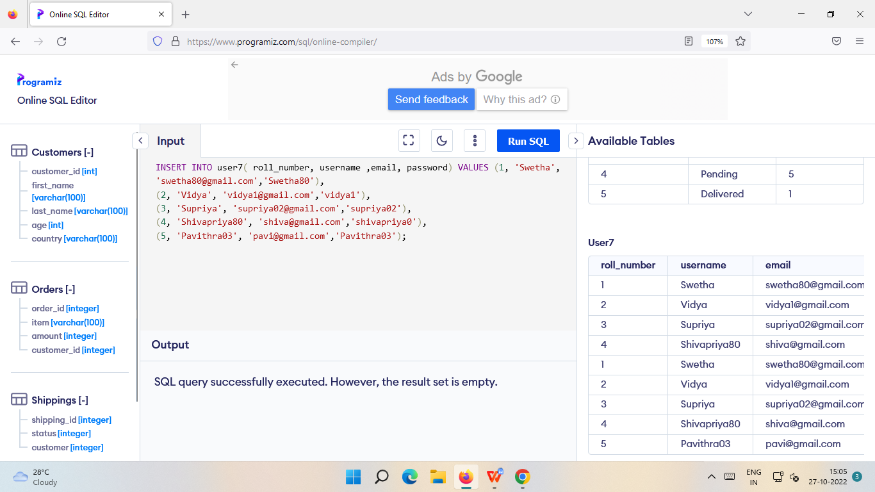

## UPDATEStatement:

UPDATEusers4SETusername='Swetha'WHEREroll_number='2';

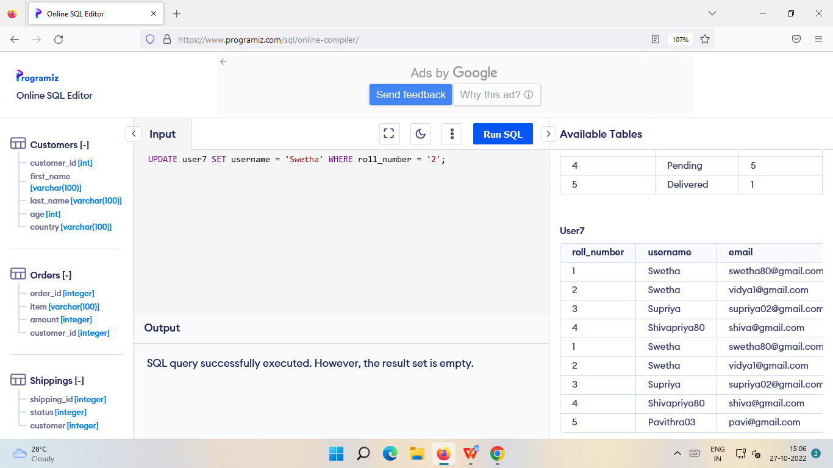

**InsertStatement:**

# INSERTINTOusers5values(5,'aa','aaa@gmail.com','aasdfg2');

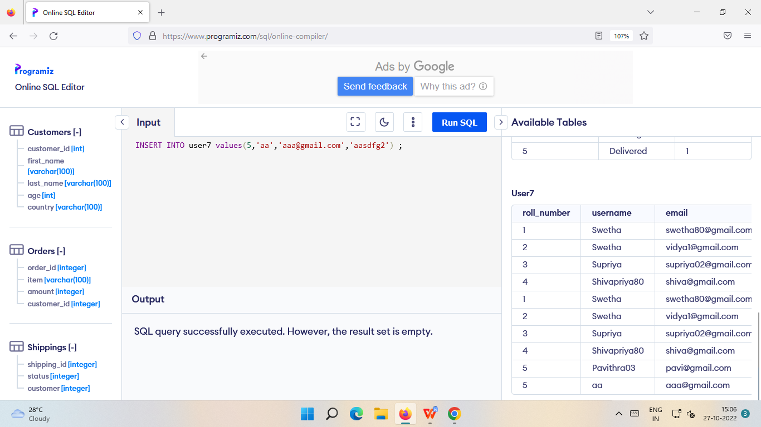

**DELETEStatement:**

DELETEFROMusers6whereroll_number='5'

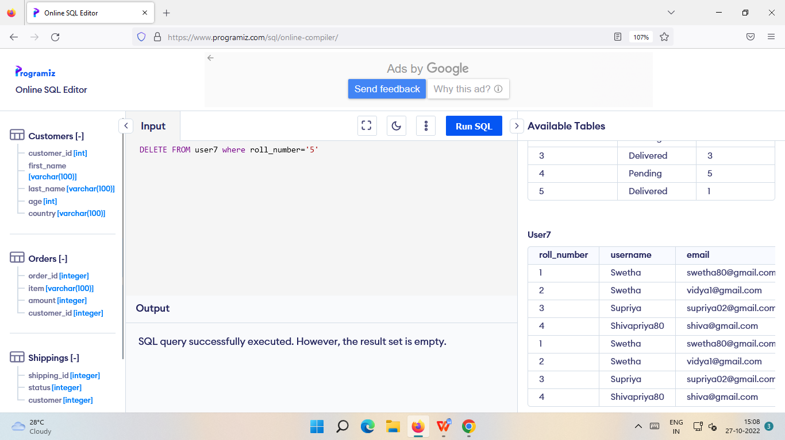

Connectpythonwithdb2

conn = ibm_db.connect("DATABASE=bludb;HOSTNAME=824dfd4d-99de-440d-9991-

629c01b3832d.bs2io90l08kqb1od8lcg.databases.appdomain.cloud;PORT=30119;SE CURITY=SSL

;SSLServerCertificate=DigiCertGlobalRootCA.crt;UID=lvq43963;PWD=BsnsG1l2sBgIRhVN",' ','')

from flask import Flask, render_template, request, redirect, url_for, sessionfromflask_mysqldb importMySQL

import MySQLdb.cursorsimportreapp=Flask(name)

app.secret_key = 'your secret key'app.config['MYSQL_HOST'] = 'localhost'app.config['MYSQL_USER'] = 'root'app.config['MYSQL_PASSWORD'] = 'your password'app.config['MYSQL_DB']= 'geeklogin'

mysql = MySQL(app)@app.route('/')

@app.route('/login', methods =['GET', 'POST'])deflogin():

msg=''ifrequest.method=='POST'and'username'inrequest.formand 'password' inrequest.form:

username = request.form['username']password=request.form['password']

cursor = mysql.connection.cursor(MySQLdb.cursors.DictCursor)cursor.execute('SELECT*FROMaccountsWHEREusername=%sANDpassword

= % s', (username, password, ))account = cursor.fetchone()ifaccount:

session['loggedin'] = Truesession['id']=account['id']

session['username'] = account['username']msg= 'Logged in successfully!'

returnrender_template('index.html',msg=msg)

else:

msg='Incorrectusername/password!'

returnrender_template('login.html',msg=msg)

@app.route('/logout')deflogout():

session.pop('loggedin', None)session.pop('id', None)session.pop('username', None)returnredirect(url_for('login'))

@app.route('/register', methods =['GET', 'POST'])defregister():

msg = ''

if request.method == 'POST' and 'username' in request.form and 'password' in request.formand'email' in request.form:

username = request.form['username']password = request.form['password']email= request.form['email']

cursor = mysql.connection.cursor(MySQLdb.cursors.DictCursor)cursor.execute('SELECT * FROM accounts WHERE username = % s', (username, ))account= cursor.fetchone()

ifaccount:

msg='Accountalreadyexists!'

elif not re.match(r'[^@]+@[^@]+\.[^@]+', email):msg= 'Invalid email address !'

elifnotre.match(r'[A-Za-z0-9]+',username):

msg = 'Username must contain only characters and numbers !'elifnot usernameor notpassword or notemail:

msg= 'Pleasefill outtheform!'

else:

cursor.execute('INSERTINTOaccountsVALUES(NULL,%s,%s, %s)',

(username,password,email,))

mysql.connection.commit()

msg = 'You have successfully registered !'elifrequest.method == 'POST':

msg= 'Pleasefill outtheform!'

returnrender_template('register.html',msg=msg)

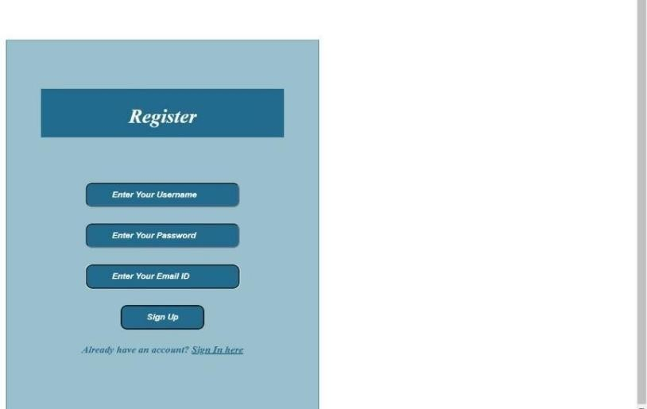

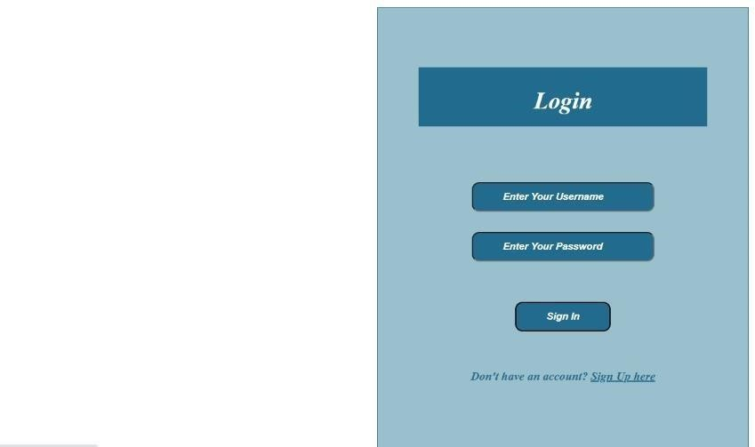

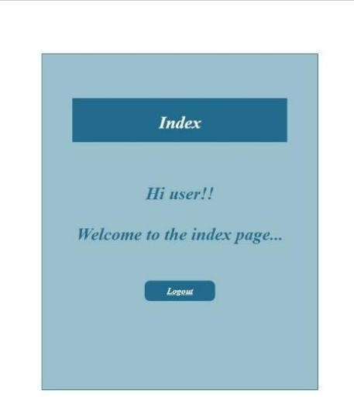

## 3) Write a flask program which should display resume details and also have uploadresumeoption

**byusing file uploading.**

## UPLOAD.PY:

fromflask import*

app= Flask(name)

@app.route('/')defupload():

returnrender_template("file_upload_form.html")

@app.route('/success', methods = ['POST'])defsuccess():

if request.method == 'POST':f = request.files['file']f.save(f.filename)

returnrender_template("success.html",name=f.filename)

if name== 'main':app.run(debug= True)

## FILE_UPLOAD_FORM.HTML:

<html>

<head>

<title>upload</title>

</head>

<body>

<formaction="/success"method="post"enctype="multipart/form-data">

<inputtype="file"name="file"/>

<inputtype="submit"value="Upload">

</form>

</body>

</html>

## SUCCESS.HTML:

<html>

<head>

<title>success</title>

</head>

<body>

<p>Fileuploadedsuccessfully</p>

<p>FileName:{{name}}</p>

</body>

</html>

## OUTPUT:

